# **Classroom Instructions**

Welcome to our English Basic Course. To start we want to show you important vocabulary from the course. Come back to this guide anytime you need:

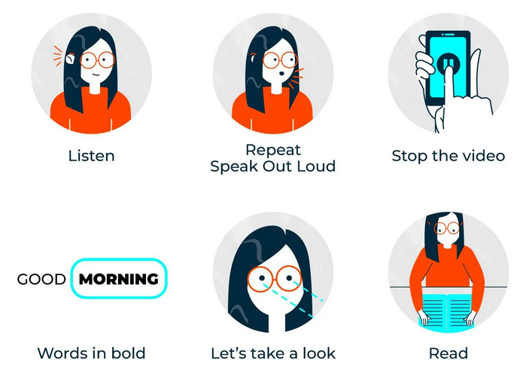

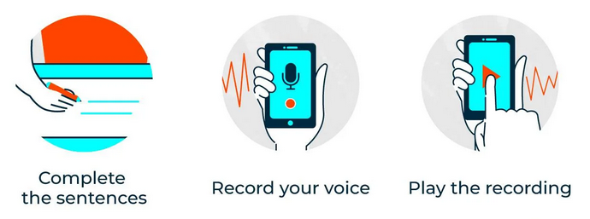

# **Grammar: Saying Hello and Goodbye**

In this lesson you will learn Hello and Goodbye greetings.

Listen and repeat after the teacher:

Hello Greetings

* Hi
* Hello
* Hello, how are you?
* Good morning
* Good afternoon
* Good evening

Goodbye Greetings:

* Bye
* Good bye
* See you
* So long!
* See you later

# **Verb to be**

In this lesson you will learn to **introduce yourself.**

I am Paula, you are my student  
I’m Paula, you’re my student

My name is Paula, what is your name?

**Compare** your conversation:

* Hello, how are you? I am Paula (your name).
* Good morning. Nice to meet you. I’m Sam.

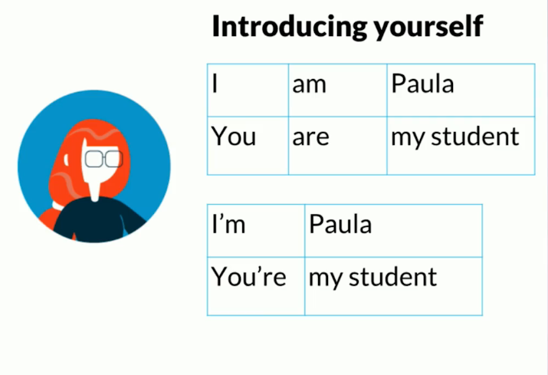

# **Discussion: Introduce yourself**

Read some of the most common questions to introduce yourself:

* What is your first name?
* How old are you?
* Where do you come from?
* What languages do you speak?

Here are three examples:

* My name is Alex. I come from Spain and I’m 26 years old. I speak Spanish, Portuguese and I’m learning English.
* I am Anabella, but my friends call me Ana. I am 19 years old and I was born in Mexico. I speak Spanish and a little bit of English.
* My name is Valeria. I am 32 years old and I come from Brazil. I speak Portuguese and I want to speak English.

Now, it’s your turn. Write your answers to the 4 questions and read what other people say! You can reply to them too to practice your English.

Also record your voice using your mobile phone and play the recording to listen to yourself.